Ques1: Write a program in Java to display the names and roll numbers of students. Initialize respective array variables for 10 students. Handle ArrayIndexOutOfBoundsExeption, so that any such problem doesn’t cause illegal termination of program.

Source Code

**package** Lab8;

**import** java.util.Scanner;

**public** **class** ArrayIndexOutOfBounds {

**public** **static** **void** main(String[] args) {

System.***out***.println("Hitendra Sisodia");

System.***out***.println("500091910");

Scanner sc = **new** Scanner(System.***in***);

String name[] = **new** String[10];

**int** roll[] = **new** **int**[10];

**for**(**int** i = 0 ; i < 10 ; i ++) {

System.***out***.print("Enter Name And roll no: ");

name[i] = sc.next();

roll[i] = sc.nextInt();

}

**try** {

System.***out***.print("Enter Index To access: ");

**int** i = sc.nextInt();

System.***out***.print("Name: "+name[i]);

System.***out***.print("Roll No: "+roll[i]);

}

**catch**(ArrayIndexOutOfBoundsException e) {

System.***out***.println(e);

}

}

}Output

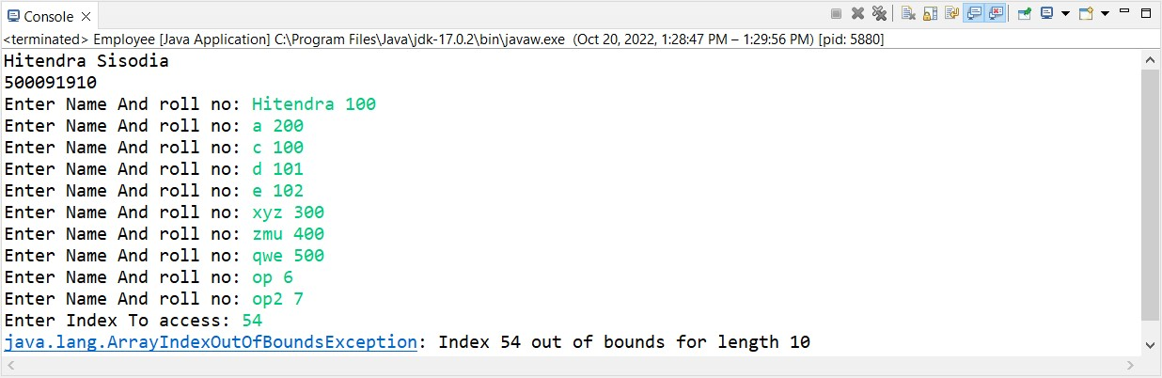

Ques2: Write a Java program to enable the user to handle any chance of divide by zero exception.

Source Code

**package** Lab8;

**import** java.util.Scanner;

**public** **class** DivideByZero {

**public** **static** **void** main(String args[]) {

System.***out***.println("Hitendra Sisodia");

System.***out***.println("500091910");

Scanner sc = **new** Scanner(System.***in***);

System.***out***.print("Enter a: ");

**int** a = sc.nextInt();

System.***out***.print("Enter b: ");

**int** b = sc.nextInt();

**try** {

**int** c = a/b;

System.***out***.print(c);

}

**catch**(ArithmeticException e) {

System.***out***.println(e);

}

}

}

Output

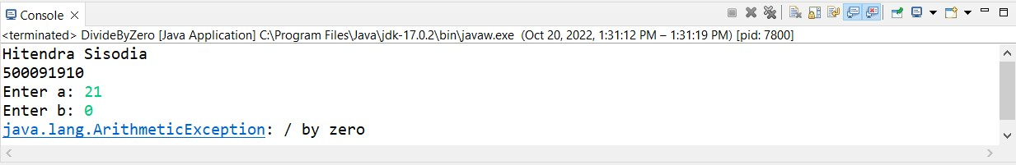

Ques3: Write a java program to throw an exception for employee details. If an employee name is a number, a name exception must be thrown. If an employee age is greater than 50, an age exception must be thrown.

Source Code

**package** Lab8;

**import** java.util.Scanner;

**class** NameException **extends** Exception{

NameException(String s) {

**super**();

}

}

**class** AgeException **extends** Exception{

AgeException(String s) {

**super**();

}

}

**public** **class** Employee {

**public** **static** **void** main(String args[]) {

System.***out***.println("Hitendra Sisodia");

System.***out***.println("500091910");

Scanner sc = **new** Scanner(System.***in***);

String name;

**int** age;

System.***out***.println("Enter employee name and age");

**try** {

name = sc.nextLine();

**if**(!name.matches("[a-zA-Z]+")) {

**throw** **new** NameException("Name Incorrect");

}

age = sc.nextInt();

**if**(age > 50) {

**throw** **new** AgeException("Age Exception");

}

}

**catch**(NameException ex) {

System.***out***.println(ex);

}

**catch**(AgeException e) {

System.***out***.println(e);

}

}

}

Output

